The Power of the Mundane
Project: Harvard Design School, Design in Paradise II.
Last Updated: 5 May 2005
Authors: Douglas Look, AIA, Jon Pittman, AIA

mun·dane [ mun dáyn ] : common, ordinary, or of this world

“The word mundane is an adjective that, when converted to a noun, describes the essence of the world from a user point of view.”—Robert R. Johnson, User-Centered Technology

Introduction

What’s the highest and best use for digital collaboration solutions like Autodesk DWF Composer and Autodesk Buzzsaw? How about striving to be mundane? Being mundane means that the technology blends into the background, that it is so easy to use you don’t have to think too hard about it, and that in some ways you take it for granted. It just works.

Rather than trying to push digital solutions on architects, engineers, and contractors as technology that changes their work practices and process, why not provide solutions that simply and transparently support and enable people to do their jobs better? Isn’t this the essence of democratizing technology? There are a host of technology solutions that promise a sea change in the entire design and construction industry from a 2D paper-based representation technology into a virtual world based on building information modeling (BIM). These new solutions promise great improvements in efficiency, cost savings, and also better designs resulting from better and more accurate data. They also require significant changes from existing process. However, in order for these high-powered building information models to have a far reaching effect, the information must be effectively created, managed, and shared.

Right now most of the attention has been focused on the create part of the equation, with the development of BIM solutions like Autodesk Revit and Autodesk Architectural Desktop. These authoring applications represent the next generation of computer aided design tools, in which a coordinated, internally consistent data model of the building is created. BIM tools are powerful, but can be a bit daunting from the user experience perspective. The other key components to an overall solution involve ways to view, revise, and manage that information. Autodesk DWF Composer enables view, markup, and revision of design information. The Autodesk Buzzsaw solution provides an easily accessible framework for managing and tracking information.

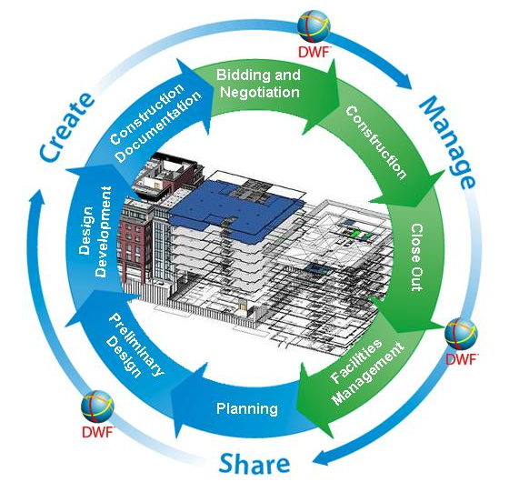
Building Lifecycle Management—Create, Manage, Share

Let’s compare the challenges of the world of portable consumer electronics like Sony’s newly introduced Playstation Portable (PSP) with the challenges of digital viewing technology for design and engineering data. What kind of comparisons are there between a portable gaming platform and the Design Web Format platform?

Sony Playstation Portable (PSP):
- Multimedia platform: movies, music, photos, games.
- Audience: consumer device designed for mass appeal
- Content: Relies on published games from multiple authoring companies
- User Interface: familiar user interface that builds upon Playstation controller buttons.
- Affordability: Value pack retails at $249, comes with protective case and power adapter.
- Performance: PSP CPU (system clock frequency: 333 MHz, 5 hour projected battery life.

Autodesk DWF Composer:
- Multimedia platform: 2D, 3D, raster images, assembly animations, bills of materials
- Audience: designers, architects, engineers, builders, owners, fabricators
- Content: relies on DWF and raster image files published out of authoring applications like AutoCAD, Autodesk Revit, Autodesk Architectural Desktop, Autodesk Inventor, Autodesk Map, Autodesk Civil 3D, Autodesk 3D Studio Max.
- User Interface: familiar windows-based user interface with multi-sheet navigator and simple set of view and markup tools; standard mouse, rollerball, or pen-based input devices.
- Affordability: Suggested retail price of $199 comes bundled with DWF Writer, DWG Viewer, Inventor View.
- Performance: Intel® Pentium® processor or later, 200 MHz or higher, or compatible.

So what’s the point? There are some relevant characteristics shared between portable gaming platforms and DWF collaboration technology—at a very basic level, each solution needs to be easy-to-use, have access to a wide range of content, and be broadly available to the mass market at an affordable price point. Further, each needs to work in a way that is familiar and easy for its users to grasp. While they serve different markets, the fundamental concept of making the mundane easy is embodied in both products.

Harvard Design School Case Study

“Working with new technologies doesn’t mean we have to reinvent the wheel—design’s purpose has always been to define and solve problems. What new technology alters is the environment in which problems reside” – Clement Mok, Designing Business

Professor Janine Clifford enlisted Autodesk as one of the sponsors for her urban design studio at the Harvard School of Design which took place from September 2004 through January 2005. Autodesk provided the class with full licenses of Autodesk DWF Composer as well as access to an Autodesk Buzzsaw Professional site. With her students located at Harvard University in Cambridge, Massachusetts, Professor Clifford, who lives and works in Hawaii, interacted with her students remotely from her offices in Honolulu

The demands of the studio meant that access to the student information had to be transportable and highly accessible from many locations. While the students at Harvard have access to the university network only while within the confines of campus, the combination of Autodesk Buzzsaw and DWF Composer provided ways to share and manage that information from anywhere, whether that was Honolulu, Cambridge, or San Francisco. In addition, the solution would need to be seamless in order to provide real value for this remote collaboration.

How did the solution work? The twelve students in the studio organized themselves into teams of two or three to develop ideas for introducing new mass transit solutions for Honolulu. This diverse group of students represented the multi-disciplinary backgrounds including urban design, architecture, and landscape architecture. Students brought and used their own hardware and software systems, including laptop computers, digital cameras, and GPS tracking systems. Hewlett Packard loaned the studio five Tablet PC’s that provided pen-based mobile solutions to document and review design information.

The students’ initial tasks included documenting the existing context. This meant traveling to Honolulu to sketch out existing conditions, develop analysis diagrams, and document information using CAD and digital images. This information was managed and tracked using Buzzsaw Professional—this provided a great way to share the information between team members. The students gathered a diverse set of information from a variety of sources – digital photographs, sketches, GIS data from the City of Honolulu, and demographic data.

Once back in Cambridge, Professor Clifford met with her students individually using remote collaboration technology at least twice a week. Using ePop, a synchronous collaboration technology that works similar to Microsoft’s Net Meeting, the students presented their designs with Autodesk DWF Composer working within Autodesk Buzzsaw Professional. Using the simple markup and redlining functionality, Professor Clifford was able to review and provide real-time critiques from Hawaii. The familiar multi-page navigator user interface of Autodesk DWF Composer enabled direct access to the information, making the solution easy to adopt for this remote collaboration. The ability to automatically save, track, and manage the markups in the Autodesk Buzzsaw site provided real value for the students and faculty. In this case, the simplicity and directness of the solution led to the perception of seamlessness—in other words, the solution achieved the goal of being mundane. Students and professor took advantage of the technology as a support system—it worked in the background and supported the true work, the remote exchange of critical ideas.

Interestingly, the students relied much more heavily on non-traditional methods in both the early conceptual design phases as well as for the final review presentations. Perhaps this had something to do with the required immediacy and need for direct contact with the media. During an onsite charrette in Honolulu with local design professionals early in the semester, there was minimal use of digital tools. The students, faculty, and professionals relied on the traditional tools of tracing paper, wide-tipped markers, and colored pencils. The interactions took place in small groups with direct, face-to-face contact.

The final review presentations yielded similar observations—the interactions were done in person, using largely non-digital techniques of reviewing design ideas expressed on paper and through the use of physical models – although much of the content being reviewed had been produced using digital techniques. In both the charrette and the final review, rapid development and sharing of ideas took place effectively without the need for supporting digital technology. Pinned sheets of drawings and physical models generally proved to be adequate media for the final presentations. Professor Clifford encouraged some students to create physical models to gain insights into their designs. In some cases this disproved some of the students’ initial assumptions about their solutions. There certainly are cases where analog representations provide a much better understanding of the issues compared to digital media. Another lesson to take away—use whatever media works and don’t limit yourself in your investigations.

The real value of digital collaboration technology comes to light when there is a need to share and manage the design information. The value of digital information becomes clear when there is a need to archive, track, and access the design information from multiple locations and by individuals in remote locations.

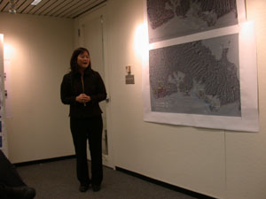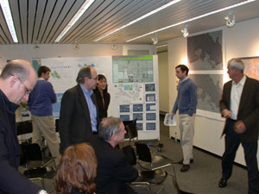
Professor Clifford at final review Final review presentations—pinned up paper prints

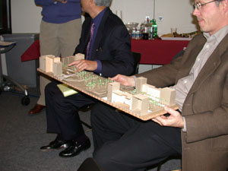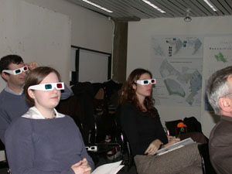
Assessment of physical model Future shock (again?) with 3D viewing glasses

National Urban Land Institute Competition

On the heels of a successful collaboration effort in the Harvard Design School studio, graduate student Cody [insert correct name] decided to enter the 2005 Urban Land Institute Competition. This competition was a national competition open to university students across the country. With an accelerated two week schedule, the student chose to collaborate again with Professor Clifford using the Autodesk DWF Composer and Autodesk Buzzsaw solution. The ability to access, review, and share information across remote locations led to a successful project—the entry gained a second prize in this prestigious national competition.

Studio Findings

Autodesk DWF Composer insights:
- User interface with access to multiple sheets within content navigator meant easier access to the information. This enabled much more effective synchronous collaboration for the review sessions, which at times included from 20 to 30 files.
- The students found it easy to organize and present their design ideas because it followed familiar metaphors and processes.
- Random access to multiple sheets provided good flexibility for presentations.
- Autodesk DWF Composer viewing solution was very appealing because it worked with not only DWF files but also TIFF and other standard raster formats, supporting the real-world use of multiple media and formats
- Markup tools enabled effective communication during synchronous review sessions.

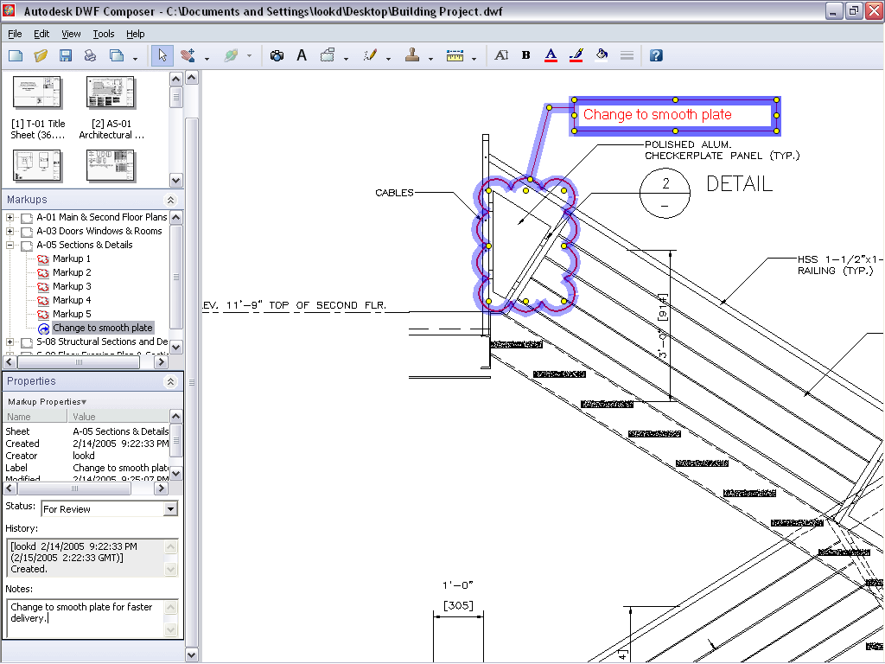

Multiple sheets, familiar user interface, with markup tools.

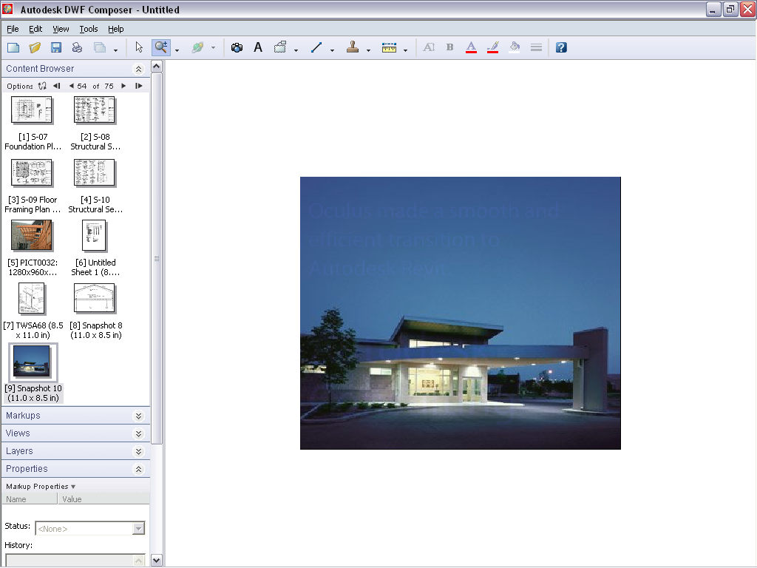

Autodesk DWF Composer aggregates different kinds of information: CAD data, raster images, text documents.

Autodesk Buzzsaw insights:
- Autodesk Buzzsaw fulfilled a real need to share and access information in a format that is location independent—it didn’t matter where the students or professor were located.
- Autodesk Buzzsaw provided distinct benefits, especially for the students who shared iterations of their design ideas amongst themselves.
- The automated tracking capabilities helped the students manage their data—they could easily determine which version of the information they were accessing, and could communicate changes using the Autodesk Buzzsaw site..
- Autodesk Buzzsaw made it easy to look at previous comments and older versions of files.
- Autodesk Buzzsaw with Autodesk DWF Composer made for a seamless collaboration solution. Files were preloaded on the Buzzsaw site, then Autodesk DWF Composer was launched and reviews were accomplished. At the conclusion of the design critique sessions, the updated files were automatically saved and tracked for everyone to access and view.

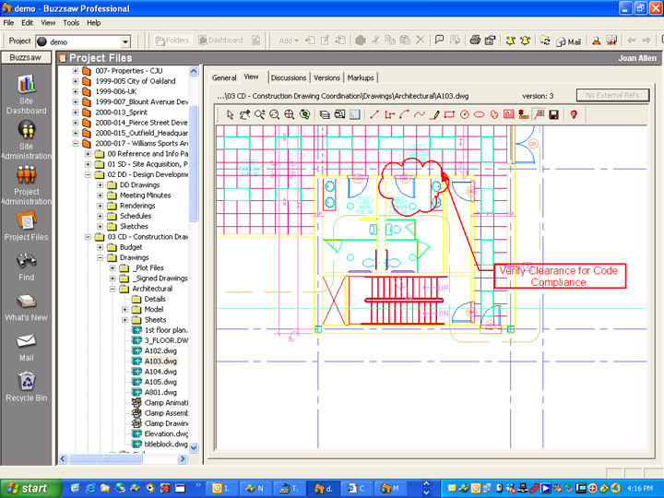

Integrated viewing components in Buzzsaw with automated management and tracking features.

In summary, the Autodesk DWF Composer and Autodesk Buzzsaw solution provided a mundane and effective solution that solved some real-world needs of this Harvard Design School studio. Autodesk Buzzsaw gave students and faculty easy ways to share and manage their design information. Autodesk DWF Composer enabled view, markup, and revision capabilities for the core media—the graphical design information. According to Professor Janine Clifford, “The Autodesk DWF Composer and Autodesk Buzzsaw solution was truly easy to use and intuitive.” In this case, Autodesk played an important role in the background as supportive and enabling technology—what a great example of the power of the mundane.

Future Research

Building upon this synergistic experience between the Harvard Design School and Autodesk, Inc., there are many other opportunities for further research and exploration.

- Human interface vs. collective knowledge base. It seems that the human interface has to be very tactile and physical – both for input and presentation. However, digital data is virtual. Creating tactile representations makes it difficult to store and communicate across distance. The more “computable” the digital representation, the more the computer can help with analysis and tasks of that nature – but the more difficult it may be to relate to the human interface. Is the collective knowledge base computable or pictorial?
- Live vs. Inert information. An interesting example of this is that the students in the class were pulling data from the Honolulu GIS database but it was “dead”, not live. They might have been able to benefit from a more live database where they could ask “what-if” kinds of questions.
- Support existing process vs. change the process. This is really the modeling vs. drawing question. Tools such as Autodesk Architectural Studio supported existing process while tools such as Autodesk Revit try to change process. Which is the appropriate approach? Our inclination is to think both but this requires a reconciliation of how the two systems can work together in an integrated solution.
- Documentation vs. Synthesis. Tools for documentation might be different than tools for synthesis – this might actually be a way to resolve the dilemma above – documentation must be concrete and literal while synthesis wants to be fluid and open-ended. If this is the case, we then need to think about how to tie synthesis and documentation representations together. Designers often use representational tools as a vehicle for thinking, a point often lost on technologists. Collaboration tools need to be tools that facilitate group thinking without interfering with the thinking and discussion process.
- Now vs. History. We need fluid ways of working now but also need a record of history – this relates the value of on using Autodesk Buzzsaw to manage and track changes.
- Individual vs. Group. Methods for sharing must be very transparent. In other words, we’re looking for ways from moving very quickly (with minimal steps) from the individual workspace (one setup for synthesis) to a collective workspace (one set up for presentation and sharing). Perhaps this is the most important theme – that good software systems supporting design processes need to be able to transform the dialog from the individual (or small team) doing synthesis to the jury or larger group doing presentation and critique.

Conclusion

Did the Autodesk solutions help Professor Clifford and her students realize their ideas?

“Absolutely—who would have thought that I could teach a design class remotely from Honolulu to Harvard? Autodesk provided me with what I needed to get things done.”—Dr. Janine Clifford, Visiting Faculty Harvard Design School

We offer a few final thoughts to consider for the future of collaboration technology. Keep it simple, because it’s not the technology that matters most. What matters most is providing easy, accessible ways to enable designers and engineers to create, manage, and share their ideas.

Douglas Look, AIA, Autodesk, Inc.
Jon Pittman, AIA, Autodesk, Inc.

References:
- Designing Business, Clement Mok
- User-Centered Technology, Rhetorical Theory for Computers and Other Mundane Artifacts, Robert R. Johnson
- The Inmates are Running the Asylum, Alan Cooper
- www.autodesk.com
- www.autodesk.com/buzzsaw
- www.autodesk.com/dwfcomposer

